# Bar Chart

**Simple Bar Chart**

From the Sample-Superstore, we choose the dimension, we take profit to the columns shelf and sub category to the rows shelf. It automatically produces a horizontal bar chart as shown below. In case it does not, you can choose the chart type from the show me tool to get the below result.

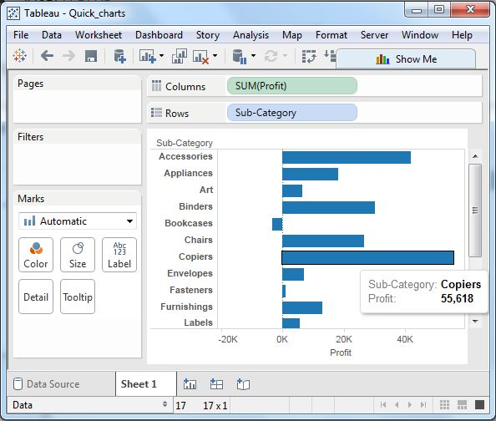

**Bar Chart with Colour Range**

We can apply colours to the bars based on their ranges. The longer bars get darker shades and the smaller bars get the lighter shades. To do this, we drag the profit field to the color pallette under the Marks Pane. Also note that, it produces a different colour for negative bars.

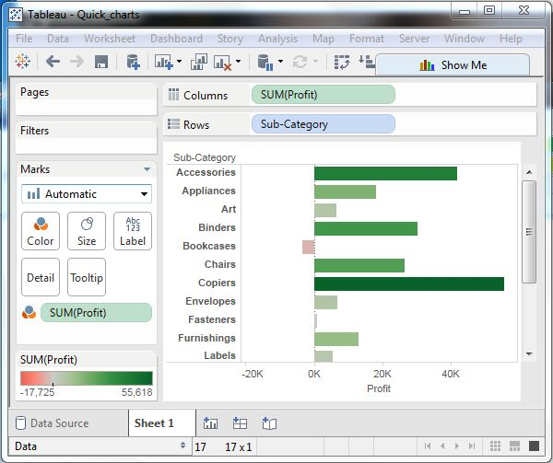

**Stacked Bar Chart**

We can add another dimension to the above bar chart to produce a stacked bar chart which shows different colours in each bar. We drag the dimension field named segment to the Marks pane and drop it in colors. The below chart appears which shows the distribution of each segment in each bar.

